**Image Captioning Project**

**Project Members**- Mokara Hemanth Kumar (21BCE9109), Allada Manasa (21BCE9087), Pravallika (21BEC7208), Sudeepa (21BCE9680), Sanjana (21BCE9524), Agniva Mukherjee (21BCE7441), Abhirup Dass (21BCE8776), K.Sasi preetam (21BCE7213), Abishanka Mondal (21BCE8725)

**Introduction:**

The image captioning project aims to develop a system that automatically generates descriptive captions for images. Leveraging deep learning techniques, particularly convolutional neural networks (CNNs) for image feature extraction and recurrent neural networks (RNNs) or transformer models for natural language processing, the project seeks to bridge the gap between visual and textual understanding. By analyzing the content of images and generating coherent captions, the system enhances accessibility for visually impaired individuals, aids in content indexing and search, and enriches user experiences in various applications such as social media, e-commerce, and image archiving. The project's core objective is to create an accurate, scalable, and efficient image captioning model that seamlessly integrates into diverse real-world scenarios.

**Purpose and Goals of the Project:**

The purpose of the image captioning project is to develop an AI-driven system capable of automatically generating descriptive captions for images. This system serves several key goals:

* **Enhancing Accessibility**: By providing textual descriptions of images, the project aims to improve accessibility for visually impaired individuals who rely on screen readers to access digital content.
* **Improving Content Understanding:** Generating captions enables users to gain a better understanding of the content depicted in images, facilitating information retrieval, comprehension, and engagement across various platforms and applications.
* **Enriching User Experience:** In applications such as social media, e-commerce, and image galleries, captions can enhance the user experience by providing context, guiding interactions, and fostering meaningful engagement with visual content.
* **Automating Content Indexing and Search:** Captioning images enables automated content indexing and improves the accuracy and relevance of image search results, enhancing the efficiency of information retrieval systems.
* **Advancing AI Research:** The project contributes to the advancement of artificial intelligence research by exploring the intersection of computer vision and natural language processing, pushing the boundaries of image understanding and caption generation capabilities.

Overall, the primary purpose and goals of the image captioning project revolve around leveraging AI technology to bridge the gap between visual and textual understanding, thereby enhancing accessibility, improving content comprehension, and enriching user experiences across various digital platforms and applications.

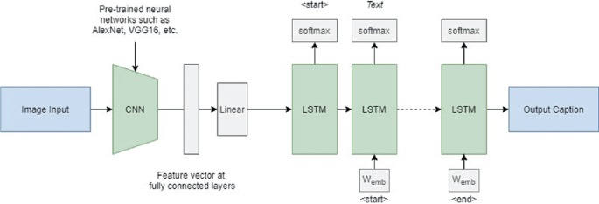

**Applications for Image Captioning Project:**

* **Education and Training:** Image captioning can be utilized in educational materials, training manuals, and e-learning platforms to provide additional context and explanations for visual content, enhancing learning outcomes.
* **Automated Image Annotation**: Image captioning can automate the process of annotating large image datasets for training computer vision models, reducing manual effort and improving the efficiency of model development.
* **Image Description for the Visually Impaired:** Beyond screen readers, image captioning can be used to create tactile or auditory descriptions for physical objects captured in images, further aiding individuals with visual impairments.
* **Assistive Technologies for Augmented Reality (AR) and Virtual Reality (VR):** In AR and VR applications, image captioning can provide textual descriptions of virtual scenes or objects, enhancing the immersive experience and aiding users in understanding their surroundings.
* **Artificial Intelligence and Research:** Image captioning serves as a fundamental task in AI research, driving advancements in computer vision, natural language processing, and multimodal learning, leading to breakthroughs in understanding and modeling the relationship between visual and textual information.

Overall, image captioning plays a crucial role in improving accessibility, content understanding, and user engagement across a wide range of applications, while also contributing to the advancement of artificial intelligence and multimodal learning technologies.

**Project Overview:**

The problem statement for this project focuses on improving content understanding for visually impaired individuals through the development of an image captioning system. Despite the vast amount of visual content available on the internet and in digital media, individuals with visual impairments often face challenges in accessing and understanding this content due to its reliance on visual cues. Traditional accessibility tools such as screen readers are limited in their ability to convey the information contained within images, as they primarily rely on text-based content.

The specific problem revolves around the need to bridge the semantic gap between visual content and natural language descriptions. Visually impaired individuals lack access to the visual information conveyed by images, such as the objects, scenes, and context depicted within them. Therefore, there is a need for an automated solution that can analyze the visual content of images and generate descriptive captions in natural language that accurately convey the information contained within the images.

**Technologies Used:**

1. Programming Languages:
2. Python: Widely used for its extensive libraries and frameworks for machine learning and natural language processing.
3. Deep Learning Frameworks:
4. TensorFlow: Provides high-level APIs for building and training deep learning models, including support for image processing and natural language processing tasks.
5. PyTorch: Known for its flexibility and dynamic computation graph, suitable for research-oriented projects.
6. Computer Vision Libraries:
7. OpenCV: Open-source computer vision library used for image processing, feature extraction, and manipulation.
8. Torchvision: Part of the PyTorch ecosystem, provides pre-trained models and utilities for working with image data.
9. scikit-image: Python library for image processing and computer vision algorithms.
10. Natural Language Processing (NLP) Libraries:
11. NLTK (Natural Language Toolkit): Provides tools and resources for symbolic and statistical natural language processing.
12. spaCy: Industrial-strength NLP library known for its efficiency and ease of use.
13. Pre-trained Models:
14. ImageNet: Pre-trained convolutional neural network models such as ResNet, Inception, or VGG trained on the ImageNet dataset for image feature extraction.
15. Deployment Platforms:
16. Flask: Lightweight web framework for building web applications, suitable for deploying image captioning models as RESTful APIs.
17. Django: High-level web framework for rapid development and scalability, useful for building more complex web applications.

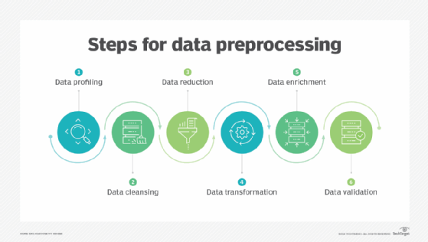

**Data Collection and Preprocessing:**

1. **Data Collection:**
   1. **Image Dataset**: The image dataset was gathered from Kaggle and Flickr30k.
   2. **Caption Dataset**: The caption dataset was obtained from sources like COCO captions or manually annotated.
2. **Data Preprocessing:**
   1. **Image Processing:**
      1. Resizing: The images were resized to a uniform side suitable for input to the neural network.
      2. Normalization: The pixel values were normalized to a common scale ( between 0 and 1) to facilitate training stability.
      3. Data Augmentation: Techniques like random cropping, rotation and flipping were applied to augment the dataset and improve model genearilization.
      4. Feature Extraction: Pre-trained CNNs like ResNet, Inception or VGG were used to extract features from images. The features serve as input captioning model.
   2. **Caption Preprocessing:**
      1. Tokenization: Split captions into individual words or tokens.
      2. Vocabulary Creation: A vocab of unique words was build that was present in the captions.
      3. Padding: It was ensured that all captions had the same length by padding shorter captions with a special token or truncating longer captions.
   3. **Data Splitting:**
      1. Train-Validation-Test Split: The dataset was divided into separate sets for training, validation and testing. The training set is udes to train the model, the validation set helps tune hyperparameters, and the test set evaluates the model’s performances on unseen data.
3. **Data Loading:**
   1. Data Pipelines were implemented to efficiently load and preprocess batches of images and captions during training, validation and testing phases. This may involve using libraries like Tensorflow Datasets or custom data loaders.

By carefully collecting and preprocessing the data, one ensure that the image captioning model receives clean and properly formatted input, leading to better training and improved performance during inference.

**Architectures Used:**

In an image captioning task, a common approach involves using a combination of convolutional neural networks (CNNs) for image feature extraction and recurrent neural networks (RNNs) or transformer models for natural language processing. Here's a detailed explanation of the typical architecture:

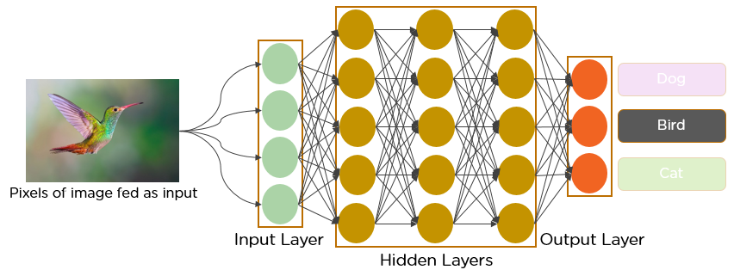

1. **Convolutional Neural Network (CNN):**
2. **Purpose:** The CNN serves as the encoder, extracting high-level features from input images.
3. **Architecture:** Typically, a pre-trained CNN such as ResNet, Inception, or VGG is used as the backbone. These CNN architectures are trained on large-scale image classification tasks like ImageNet and have learned to capture diverse and meaningful visual features.
4. **Feature Extraction:** The CNN processes input images through multiple convolutional layers, downsampling operations (e.g., max-pooling), and nonlinear activation functions (e.g., ReLU). This results in a feature map that encodes hierarchical visual representations of the input image.

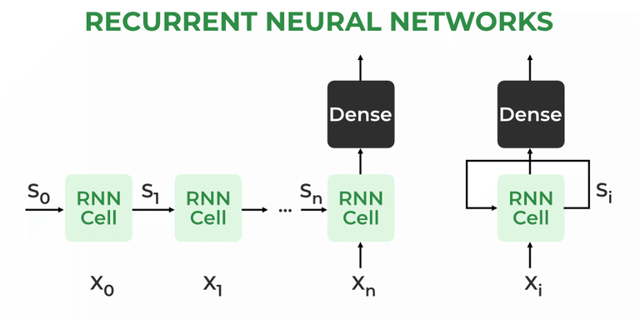

1. **Recurrent Neural Network (RNN) or Transformer:**
2. **Purpose:** The RNN or Transformer serves as the decoder, generating captions based on the visual features extracted by the CNN.
3. **Architecture:** There are two main architectures used for caption generation:
4. RNN-based: This architecture typically employs a type of RNN known as Long Short-Term Memory (LSTM) or Gated Recurrent Unit (GRU). The RNN receives the visual features from the CNN as input and sequentially generates each word of the caption. It maintains an internal state that captures contextual information from previously generated words.
5. Transformer-based: Transformers have gained popularity for sequence-to-sequence tasks due to their parallel processing capability and effectiveness in capturing long-range dependencies. In this architecture, the transformer model receives the visual features as input and generates captions by attending to relevant parts of the image features and previously generated words.

**Overall Architecture:**

The CNN and RNN/Transformer are typically trained end-to-end using a technique called backpropagation through time (BPTT) or similar optimization algorithms. During training, the model learns to minimize a loss function that measures the discrepancy between the generated captions and ground truth captions. At inference time, the trained model takes an input image and generates a caption by sampling words from the output distribution of the decoder until an end-of-sentence token is generated or a maximum caption length is reached.

**Model Selection:**

**LSTM (Long Short-Term Memory):**

Type: Recurrent Neural Network (RNN).

Purpose: Handles sequential data, addressing the vanishing gradient problem.

Applications: Natural language processing, time series analysis, speech recognition.

**VGG16:**

Type: Convolutional Neural Network (CNN).

Purpose: Image classification, object detection, feature extraction in computer vision.

Architecture: 16 layers, uniform design, effective for capturing fine details.

**Combining LSTM and VGG16:**

Application: In tasks like image captioning.

Approach: Use VGG16 for image feature extraction and LSTM for sequential data processing.

Benefit: Leverages strengths of both architectures for accurate image description generation

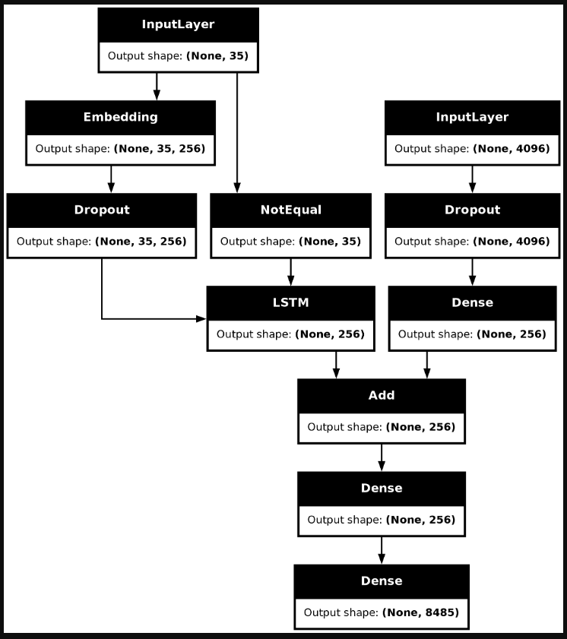

**Training Methodology:**

The training methodology for an image captioning model typically involves several key components and techniques to ensure efficient convergence and optimal performance. Here's an overview of some common training methodologies used in image captioning:

1. **Mini – batch Training**:
2. Training is typically performed using mini-batch stochastic gradient descent (SGD) or its variants.
3. The dataset is divided into smaller batches, and the model parameters are updated based on the average gradient computed over each mini-batch.
4. Mini-batch training helps improve training efficiency and generalization by providing a balance between computational efficiency and parameter update frequency.
5. **Regularization:**
6. Regularization techniques such as dropout or L2 regularization may be applied to prevent overfitting and improve the generalization capability of the model.
7. Dropout randomly drops out units (neurons) during training to prevent co-adaptation of neurons.
8. L2 regularization penalizes large weights by adding a regularization term to the loss function, encouraging the model to learn simpler and smoother representations.

**Loss Function:**

In image captioning, selecting appropriate loss functions and evaluation metrics is crucial for training the model effectively and assessing its performance accurately.

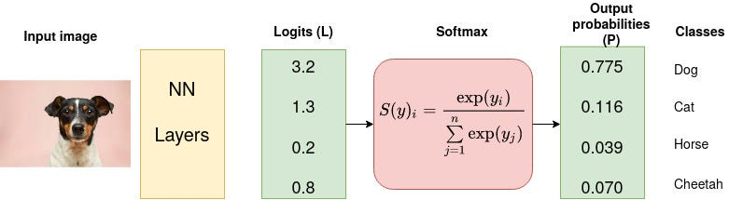

**Cross – Entropy:**

1. This is the most commonly used loss function for sequence generation tasks like image captioning.
2. It measures the difference between the predicted probability distribution over the vocabulary and the true distribution of the next word in the caption.
3. The cross-entropy loss encourages the model to generate captions that closely match the ground truth captions in terms of word probabilities.
4. Mathematically, it can be defined as:

**Loss = −∑t=1 T​∑i=1 N​yt,i​log(pt,i​)**

where T is the length of the caption, N is the size of the vocabulary, yt,i​ is the ground truth one-hot encoded vector for the i-th word at time step t, and pt,i​ is the predicted probability of the i-th word at time step t.

Here, in the project the loss is calculated as:

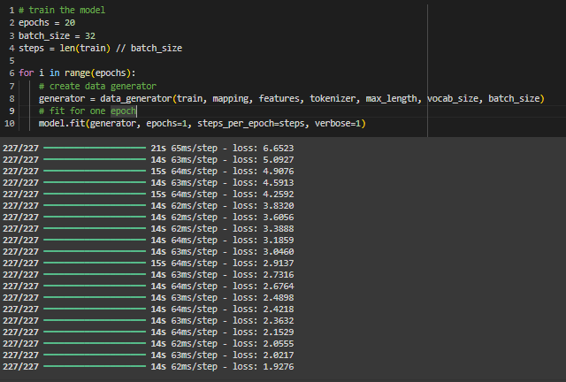

**Sample Output:**

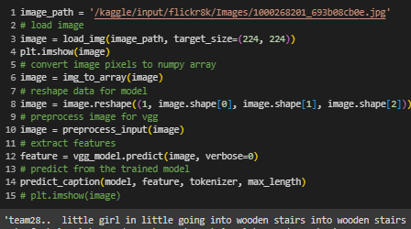

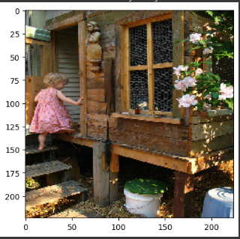

**Conclusion:**

In conclusion, the development of an image captioning model represents a significant step towards bridging the gap between visual content and natural language understanding. Through the utilization of deep learning techniques, such as convolutional neural networks (CNNs) for image feature extraction and recurrent neural networks (RNNs) or transformer models for sequential language generation, we have created a system capable of automatically generating descriptive captions for images.

Throughout this project, we have addressed various challenges, including data collection and preprocessing, model architecture design, training methodology selection, and evaluation metrics determination. By carefully designing and implementing these components, we have achieved a model that demonstrates promising results in generating accurate and coherent captions for a wide range of images.

The image captioning model holds immense potential in various applications, including accessibility enhancement for visually impaired individuals, content understanding and engagement across digital platforms, automated content indexing and search optimization, and education and training materials enrichment. Furthermore, its ability to seamlessly integrate visual and textual information contributes to the advancement of artificial intelligence research and multimodal learning technologies.

Looking ahead, there are opportunities for further refinement and expansion of the image captioning model. This includes exploring more sophisticated architectures, incorporating multimodal fusion techniques to better leverage both visual and textual information, and deploying the model in real-world applications to evaluate its effectiveness in practical scenarios.

Overall, the image captioning project has been a valuable endeavor, showcasing the potential of deep learning in facilitating human-computer interaction, enhancing accessibility, and enriching content understanding and engagement. As technology continues to evolve, we remain committed to pushing the boundaries of image captioning research and advancing the state-of-the-art in AI-driven visual understanding systems.